***Question 1:***

For the first question, I tried to solve the inequation. After getting to some point of the question, I started to try some values. Also, I used online tools to help me to solve the question. ([https://www.wolframalpha.com/input?i=100n%5E2+<+2%5En](https://www.wolframalpha.com/input?i=100n%5E2+%3c+2%5En) )

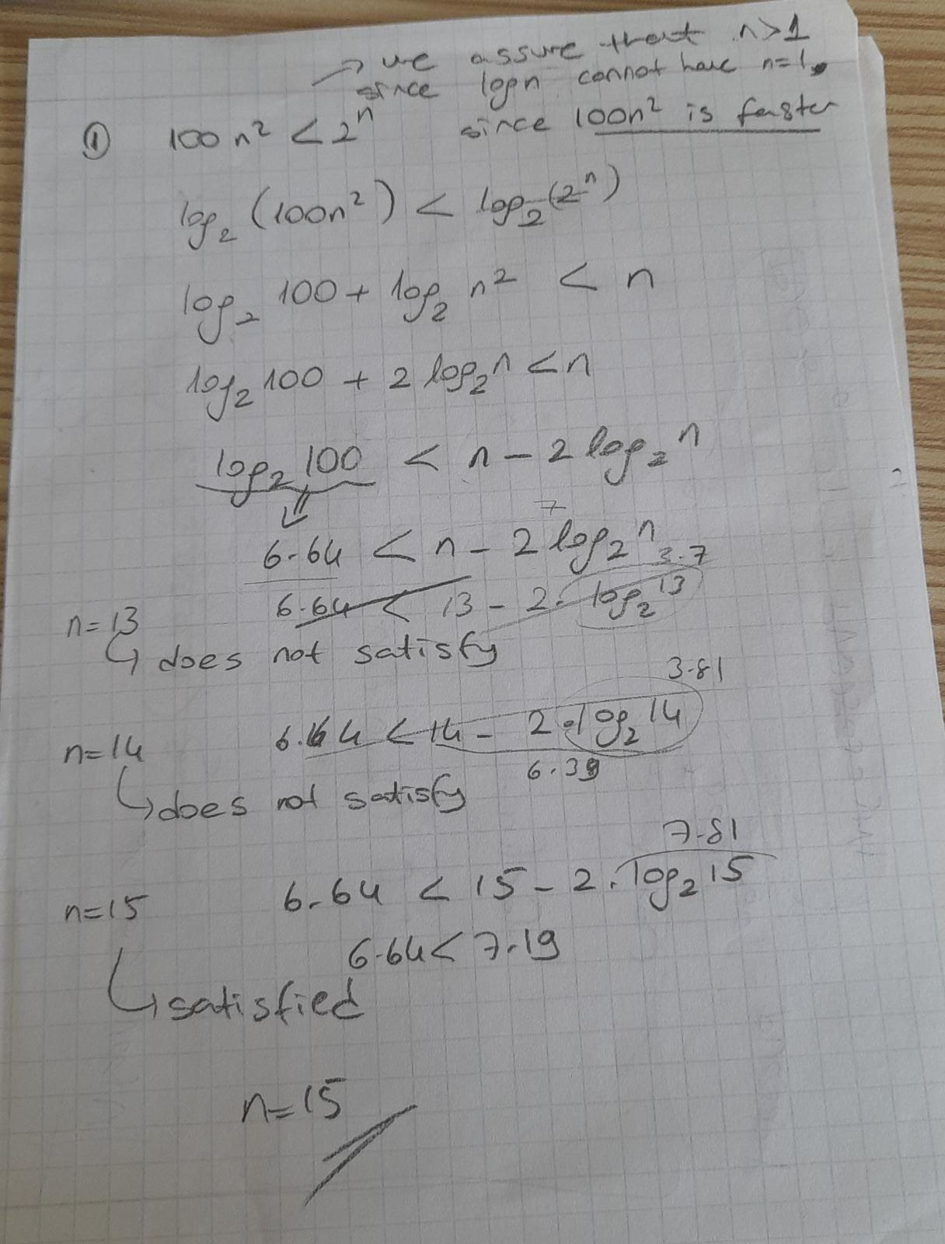

***Question 2:***

***nlog(n) & n! Codes are in the class “question2.java”***

|  |  |  |  |  |  |  |  |
| --- | --- | --- | --- | --- | --- | --- | --- |
|  | 1 sec | 1 min | 1 hour | 1 day | 1 month | 1 year | 1 cen |
| lgn | 2^(10^6) | 2^(6*10^7) | 2^(36*10^8) | 2^(864*10^8) | 2^(25920*10^8) | 2^(315360*10^8) | 2^(31556736*10^8) |
| n^(1/2) | 10^12 | 36*10^14 | 1296*10^16 | 746496*10^16 | 6718464*10^18 | 994519296*10^18 | 995827586973696*10^16 |
| n | 10^6 | 6*10^7 | 36*10^8 | 864*10^8 | 2592*10^9 | 31536*10^9 | 31556736*10^8 |
| nlog(n) | 62746 | 2801417 | 133378058 | 2755147513 | 71870856404 | 797633893349 | 68654697441062 |
| n^(2) | 1000 | 7745 | 60000 | 293938 | 1609968 | 5615692 | 56175382 |
| n^(3) | 100 | 391 | 1532 | 4420 | 13736 | 31593 | 146677 |
| 2^(n) | 19 | 25 | 31 | 36 | 41 | 44 | 51 |
| n! | 9 | 11 | 12 | 13 | 15 | 16 | 17 |

***Note: I added all of the running comprasions into the class “question2_all.java”. I tried to find the values but when the time got bigger my computer did not execute them. That’s why I used this website:*** [***https://www.wolframalpha.com***](https://www.wolframalpha.com)